**Overall Changes**

* **Create a chatbot.**
* **Fonts to use only:** 
  + ***Cormorant Garamond Semi Bold*** o***Cormorant Garamond Light*** o***Cormorant Garamond Light Regular*** o***Spinnaker***
  + ***Dancing Script Regular* (Only where "Magnoliya Grand**

**Manor" is written by itself or when it fits stylistically)** o***Adobe Caslon*** o***Playfair Display***

* **360° pictures of Magnoliya will be provided and should be integrated.**
* **Remove entire section:** 
  + **“Welcome to Grenda”**
  + **The “Baby Shower, Wedding, and Event Planning” section below it.**

**Home Page (Update)**

**Photo Slides**

1. **Slide 1:**

*"Whether you're planning a dream wedding, an elegant business meeting, a joyful family celebration, or anything in between, our venue is here to bring your vision to life. From romantic wedding receptions to corporate events and private parties, we provide the perfect blend of grandeur, exceptional hospitality, and personalized service. Step into a world where every detail is designed to create unforgettable moments you and your guests will cherish forever."*

1. **Slide 2:**

*"Whether you're planning an intimate corporate retreat, a grand gala, or a dream wedding, our venues are thoughtfully designed to meet your unique needs. With advanced audiovisual capabilities and flexible configurations, your event will shine at MgM."*

1. **Slide 3:**

*"Located just outside the bustling capital city of Washington, D.C., and only minutes from Dulles International Airport (IAD), MGM offers the ideal blend of convenience and tranquility. Our prime location makes us a sought-after choice for weddings, corporate events, and special celebrations, providing guests with easy access while surrounding them in a elegant, picturesque setting perfect for unforgettable memories."*

**About Us (Update)**

**Replace current text with:**

*"Our state-of-the-art event center, conveniently attached to the*

*Hilton Garden Inn hotel, offers a variety of versatile spaces perfect for gatherings of all sizes and occasions. Whether you're hosting an intimate corporate retreat, a lavish gala, or your dream wedding, our venues are thoughtfully designed to meet your unique needs. With advanced audiovisual technology, elegant décor, and flexible room configurations, every event at Magnoliya Grand is set to impress.* *Located just outside Washington, D.C., and only minutes from Dulles International Airport (IAD), Magnoliya Grand combines accessibility with serenity. Surrounded by picturesque settings like Battlefield Park and featuring ample on-site parking, we are the ideal choice for wedding ceremonies, receptions, corporate events, and special occasions."* **Also:**

* Replace **image** to the left of this section with this:

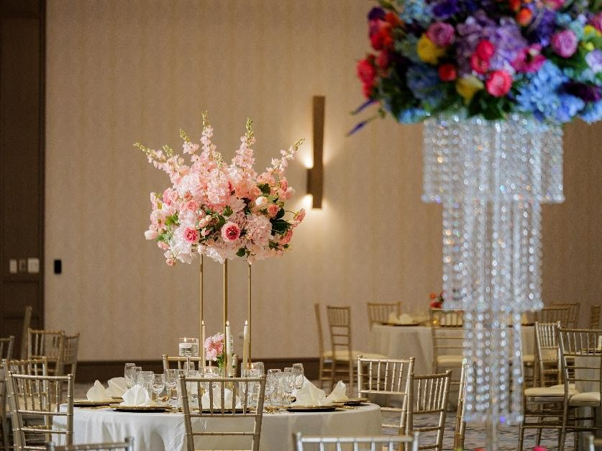

•

•

* **Remove gallery** beneath.
* Keep **everything else on the homepage** as-is.

**Testimonials**

* Match visual **style and layout** to this, photos don’t need to be included.

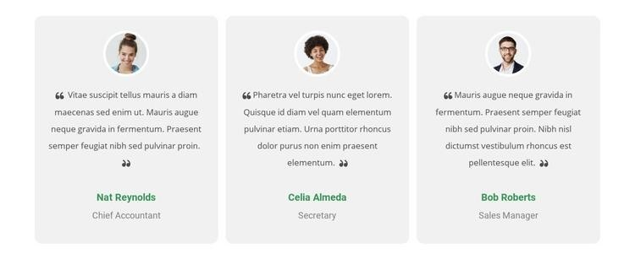

* Use **Google Reviews** for review content, and include 5 stars in each of the reviews.

**Room & Suites Page**

* **No changes needed.**

**Dining Page**

**Top Section**

**Headline:** “Culinary Excellence” **Text:**

*"Embark on an exquisite journey at our world-class restaurants, where master chefs craft extraordinary dining experiences tailored for every occasion. From elegant wedding receptions and lavish banquets to corporate luncheons and private celebrations, our culinary team delivers exquisite flavors, artful presentation, and unforgettable moments for you and your guests."*

**Our Signature Restaurants**

1. **Magnoliya Multi Cuisine Restaurant**

**Subheading:** *Fine Dining from Around the World*

*"Magnoliya offers fine dining from around the world in an elegant setting, making it a premier destination for beautiful events. Known for its diverse international menu and warm hospitality, Magnoliya has hosted countless weddings, birthdays, anniversaries, and corporate gatherings—each tailored to reflect the unique tastes and traditions of its guests. Whether it's a grand celebration or an intimate affair, every occasion at Magnoliya is marked by exceptional cuisine, personalized service, and a truly memorable experience."*

1. **Garden and Grille Restaurant and Bar**

*"Located within the Hilton Garden Inn, just steps away from our main venue, the Garden and Grille Restaurant and Bar has been serving hotel guests and local diners since its opening in 2020. Known for its relaxed yet refined atmosphere, the restaurant offers a diverse menu of freshly prepared dishes, handcrafted cocktails, and classic favorites—perfect for breakfast, lunch, dinner, or a casual drink. Whether you're attending an event at our venue or staying at the Hilton Garden Inn, Garden and Grille provides a convenient and satisfying dining experience for travelers, business guests, and locals alike."*

**Remove:**

* + “Chef’s Recommendation”
  + “Make a Reservation”
  + “View Menu” sections

**Event Venues Page**

* + **Move photo gallery to the top of the page.**
  + For the **Grand Ballroom image**, include this :

\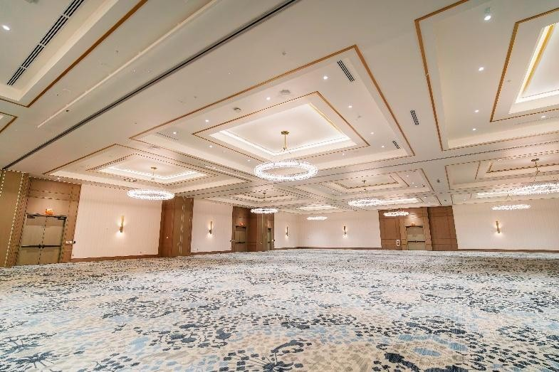

* + Instead of ‘**Small ballrooms’** title it **‘Half Ballroom’** and use this picture:

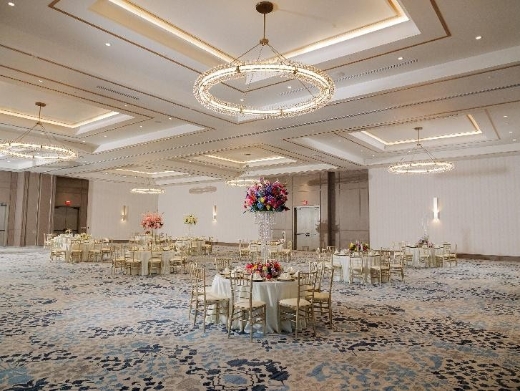

* + Please change **‘Garden Area’** to **‘Lakeview Terrace’** and make the picture:

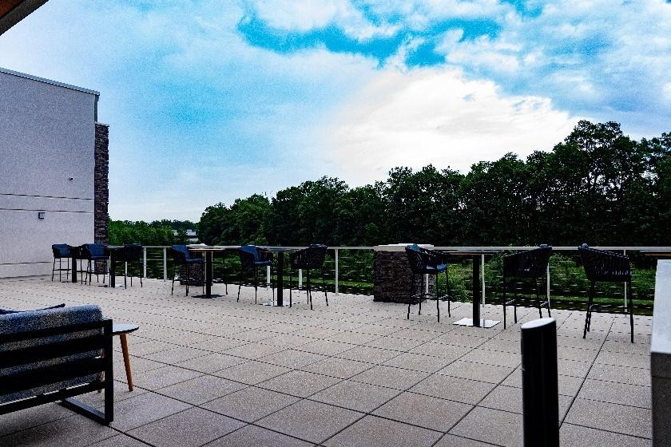

* + Change **‘Rooftop Terrace’** to **‘Front Pre-function Area’** and use this photo:

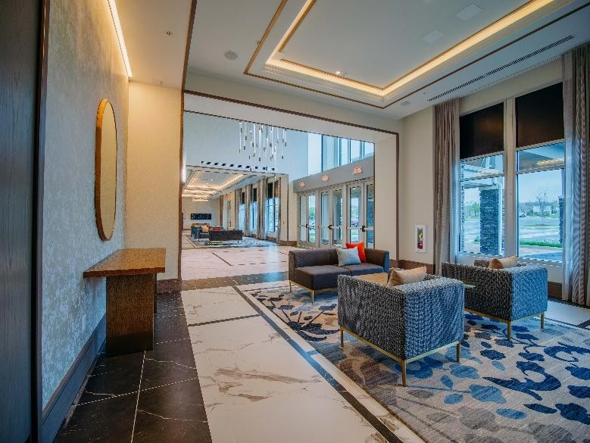

* + Change ‘**Waterview Lounge’** to ‘**Back Pre-Function’** and make this the photo:

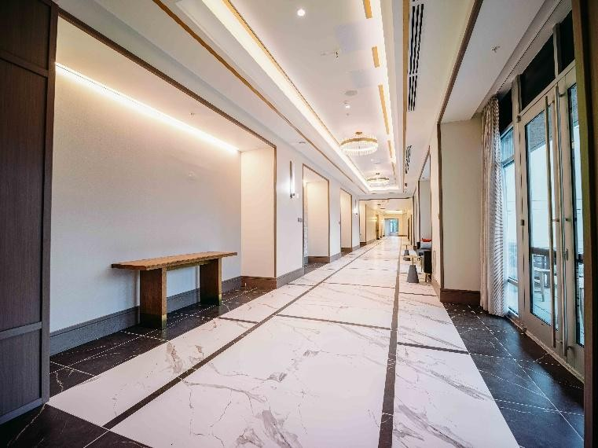

* + Change **‘Event Services’** to **‘Side Pre-Function** **& Grand Staircase’**

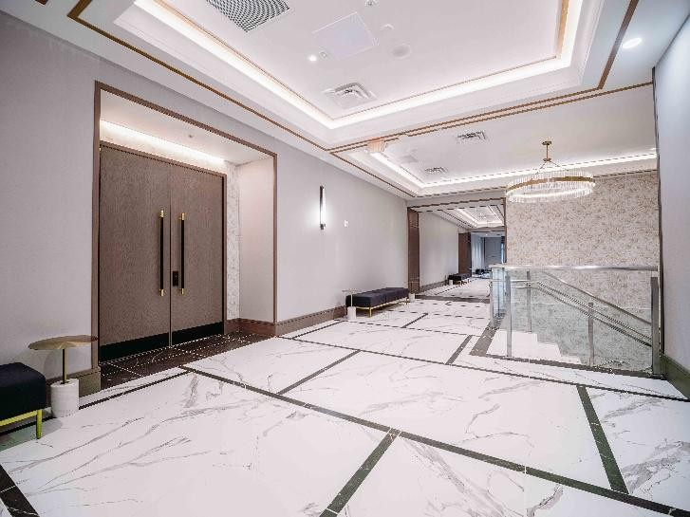

**Venue Details / Layout Section**   **Rename Titles & Adjust Content**

* + **Change**:
    - “Capacity and Layout Options” → **“Full Ballroom**

**Capacity and Layout Options”** o“Venue Capacity Summary Layout” → **“Venue Capacity Summary”**

* + **Remove**:
    - **“Classroom Style”** from layout types
    - **All layout images** under “Venue Capacity Summary Layout”
  + **Keep Only**:
    - Banquet style: **1000** oTheater style: **1200** **Specifications Table**
  + **Convert current specifications** into a clean **table layout**.
  + **Match visual style** similar to the table you referenced (please provide it if you'd like me to design it exactly).
  + Example format:

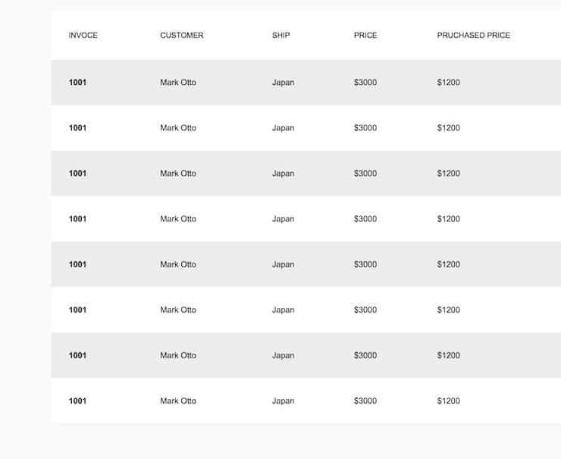

**Buttons & Section Clean-Up** o**Change “Book this layout”** → **“Book now”** o**Remove entire “Advantages and Disadvantages” section**

**Weddings & Social Events Page** → now **Weddings Page**

**Header & Background**

* + **Rename page:**

“Weddings & Social Events” → **“Weddings”**

* + **Change background image** to the image below.
  + **Add a warm beige/pink overlay** to the photo match brand color.

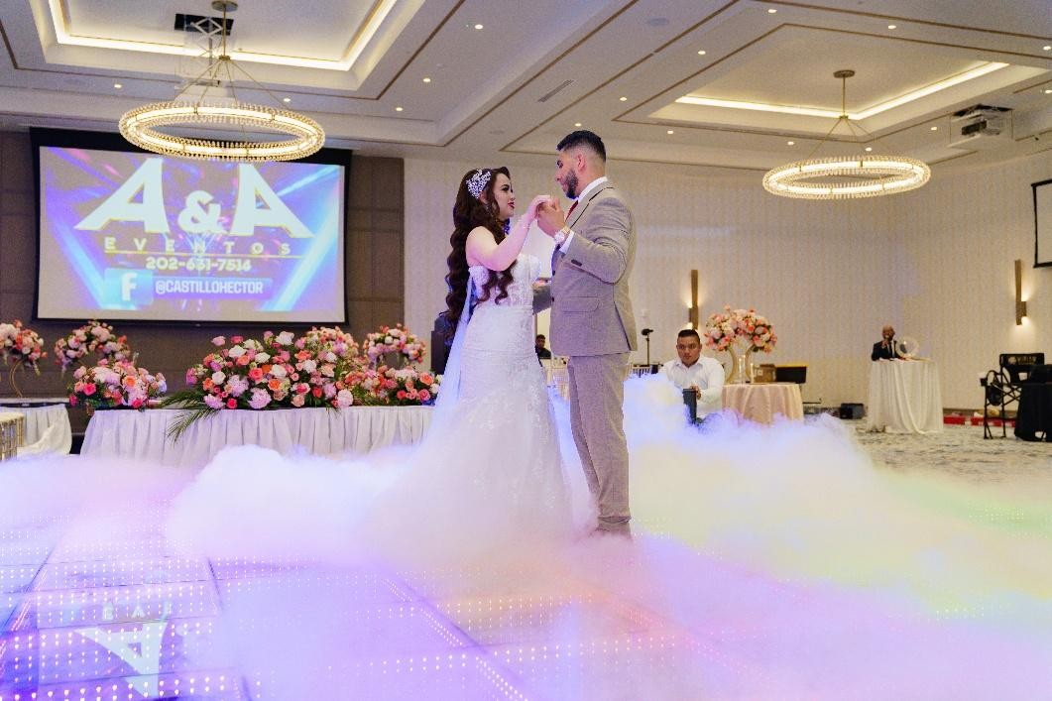

**Content Changes**

* + **Rename section** “Our Wedding & Event Offerings” → **“Our Wedding Offerings”**
  + **Replace 4 white boxes** content with:
    1. **Ceremonies** – Traditional, modern, cultural, or themed
    2. **Receptions** – Elegant dining, lively dancing, and unforgettable memories
    3. **Rehearsal Dinners** – Private and beautifully curated events
    4. **Bridal Showers & Engagement Parties** – Celebrate every milestone in style
  + **Remove entire section below** titled ‘We Make Every Moment

Special’.

**For our wedding gallery please use these photos (you do not need to label them)**

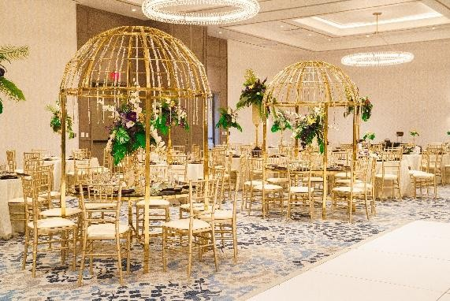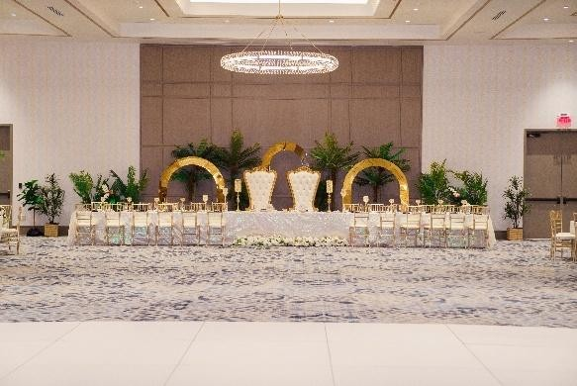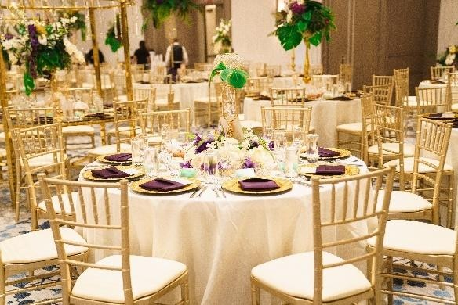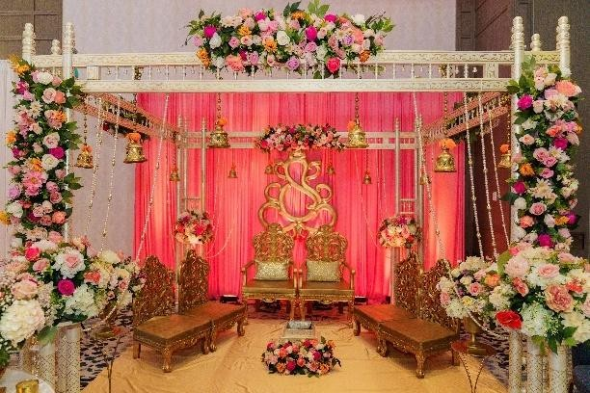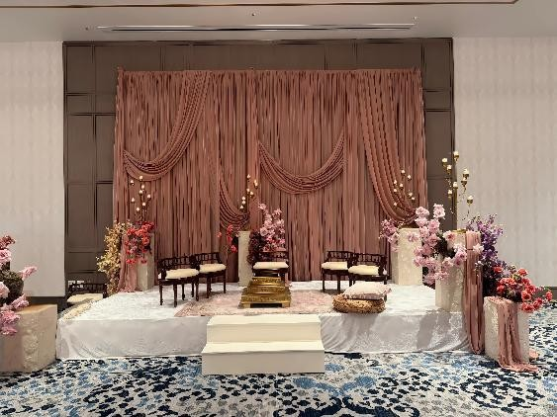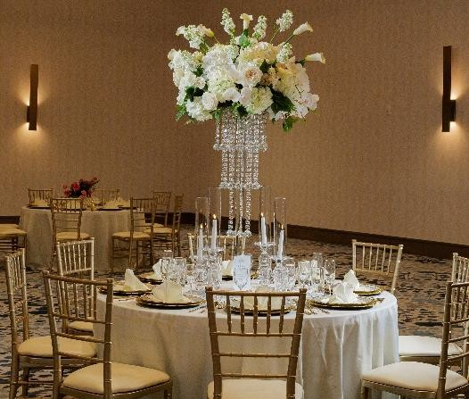

**Corporate Events Tab → now Corporate & Social Events Page**

**Header**

* + **Rename page: “Corporate Events” → “Corporate & Social Events”**
  + **Update top banner image with the image below.** •**Keep the title: *“Corporate & Social Events”***

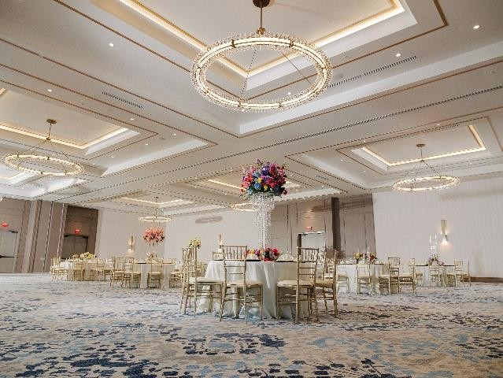

**Section 2: Social Events**

* + **Add new titled section: “Social Events”**
  + **Include sub-sections with bullet points for each:** 
    - **Birthdays** 
      * **Themed parties**
      * **Milestone celebrations**
      * **Custom decorations** o**Graduations**
      * **High school, college, post-grad events**
      * **Family-style or formal dinners** o**Reunions**
      * **Class or family reunions**
      * **Multimedia displays & memory walls**

**Remove Entirely**

* + **“Business-class Amenities” section**
  + **Entire “Event Services” Page**

**Gallery Page**

* + **Create gallery in style below.**
  + **ONLY use photos from:**

**pronine.pixieset.com/magnoliya/magnoliya**

* + **No labels or categories**
  + **All photos should be expandable on click**



**About Us Page**

* + **Under “Story Of Magnoliya Grand Manor”:** 
    - **Use only photos from the Pixieset link** o**No labels necessary**
  + **Remove “Our Team” section completely**

**Contact Us Page**

* + **Add a new tab titled “FAQs”**

**New FAQ Page**

* + **Remove any questions regarding:** 
    - **Cancellation Policy** o**Event Services**